Instructions to Prepare for the Workshop: “Experimental Design and Analysis Methods for Developing Adaptive Interventions: Getting SMART”
June 19, 20 in Ann Arbor, Michigan
1. Download all workshop files to your computer
a. Create a new folder on your computer
b. Unzip the Workshop Files.ZIP folder attached to this email
c. Save all of the files and folders from the ZIP folder into your newly created folder
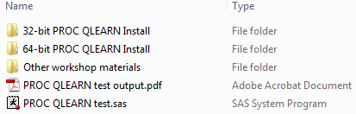
d. Contents:

e. Keep the new folder open. In step 3, you will access the 32-bit or the 64-bit Install folders.
f. Note: It is useful to print this handout before you continue.

2. Identify whether you have 32‐bit SAS or 64‐bit SAS
Note: a 64-bit computer can run 32-bit SAS
a. Open SAS version 9.x (Note: SAS Enterprise Guide is NOT SAS)
b. Click on the HELP -> ABOUT SAS 9 menu option
c. “64” (in the area shown below) indicates 64‐bit SAS,
“32,” “XP_PRO,” and all other notations indicate 32-bit SAS
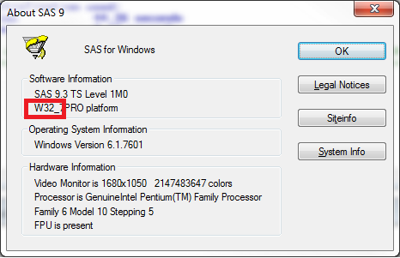

d. Close SAS
3. From the folder created in step 1, open the “32-bit install” folder or the “64-bit install” folder depending on whether you have 32-bit SAS or 64-bit SAS
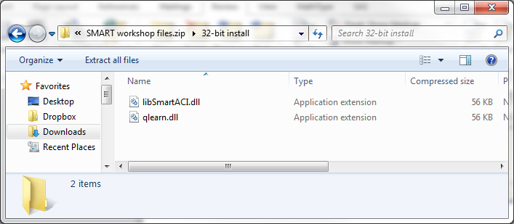

Go to next page for step 4.
4. Next, look for and open the folder containing the SAS executable file (sas.exe)

a. Right-click on the SAS 9 icon on the desktop or in the Start menu
b. In the menu that opens, select “Open File Location”. The proper folder will open.
(If you do not see this option, see below for Alternative Instructions.)
from desktop shortcut from Start menu .
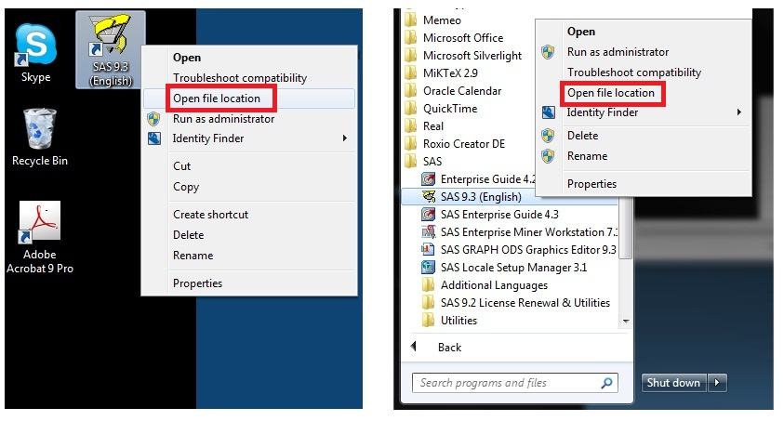
Alternative Instructions: If the menu does not include the “Open file location” option:
b. In the menu that opens, select "Properties." A popup screen will open.
c. Click the "Find Target" button. The proper folder will open.
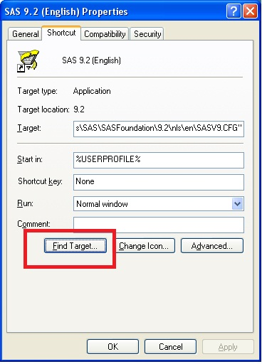

5. Move libSmartACI.dll from the install folder opened in step 3 to the folder you opened in step 4.

Note: Move the file directly into the same folder containing the sas.exe file. Do not create a subfolder.
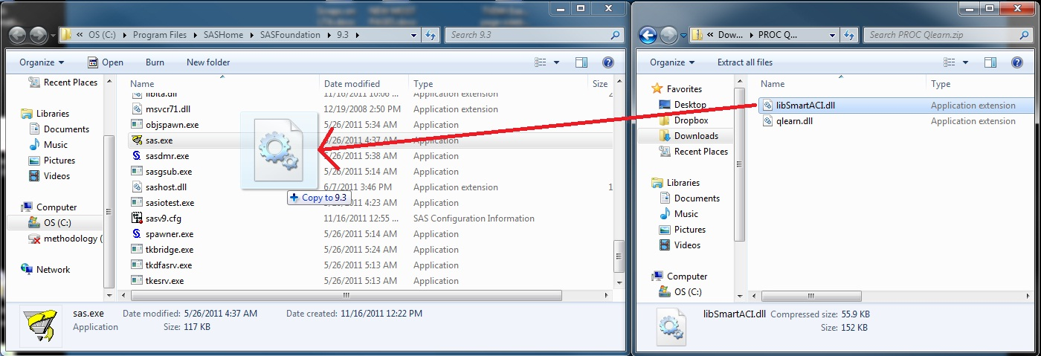

Go to next page for step 6.
6. In the same folder (where you just placed libSmartACI.dll), go to the sub-directory “\core\sasexe”
a. You can do this by following one of these two steps:
i. Type “\core\sasexe” at the end of the directory path, or
ii. Double-click on the “core” folder in the open window. Then, double click on the “sasexe” folder within the “core” folder.
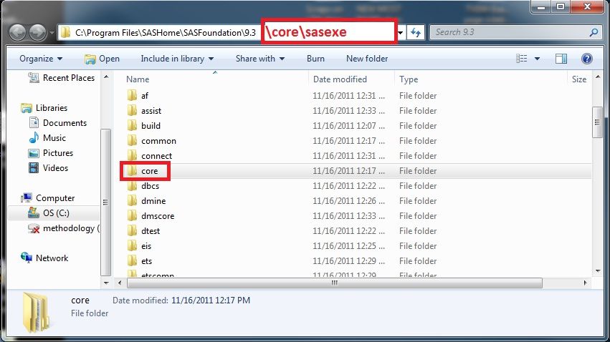

7. Move the file qlearn.dll to the newly opened folder
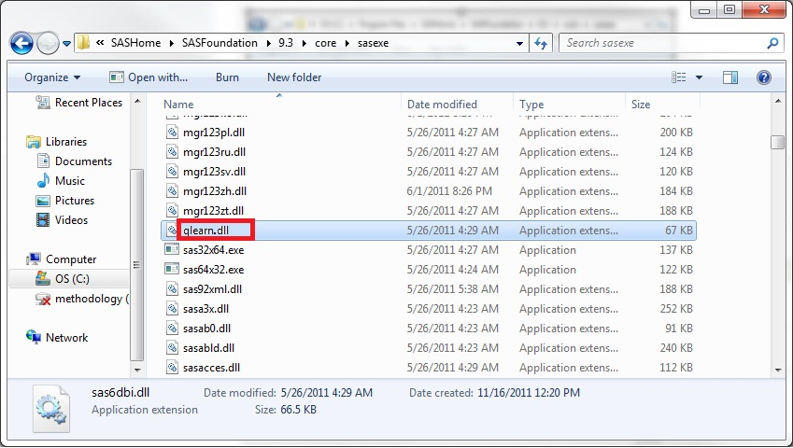
a. Close the \core\sasexe window.

8. Open the file “PROC QLEARN test.sas” in SAS
Note: this file is located in the folder you created in step 1, above.
- Right-click on the file and select “Open with SAS 9.xx”.

- Note: If “Open with SAS 9.xx” is not an option when you right-click, then launch SAS and open the file from within SAS.
- Note: Do not open in SAS Enterprise Guide

9. Run the test file
a. Run the code by doing one of the following:
i. press F8
ii. Click on the RUN -> SUBMIT menu option
iii. Click the icon of the running man
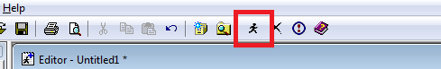

10. Compare the results in the SAS Output window to “PROC QLEARN test output.pdf”
Note: The ‘PROC QLEARN test output.pdf’ file is located in the folder you created in step 1, above.
a. If the results match, congratulations! You successfully installed PROC QLEARN and ran an example SAS file. You are ready for the workshop!
b. If the results do not match, please contact dalmiral@isr.umich.edu with any questions.

